# [**Christopher Meloni As ‘SVU’ Character Elliot Stabler To Headline New Dick Wolf Drama Series For NBC**](https://deadline.com/2020/03/christopher-meloni-returns-new-dick-wolf-series-elliot-stabler-nbc-law-order-svu-1202896323/)

[**Christopher Meloni como personagem ‘SVU’ Elliot Stabler para encabeçar nova série drama de Dick Wolf para NBC**](https://deadline.com/2020/03/christopher-meloni-returns-new-dick-wolf-series-elliot-stabler-nbc-law-order-svu-1202896323/)



By [Nellie Andreeva](https://deadline.com/author/nellie/)

### [**Nellie Andreeva**](https://deadline.com/author/nellie/)

*Co-Editor-in-Chief, TV*

March 31, 2020 12:08pm

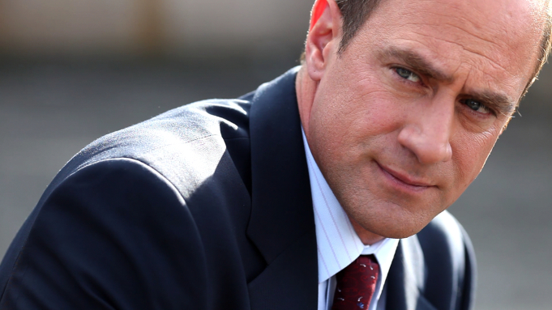NBC

**EXCLUSIVE**: A beloved TV character is coming back. [NBC](https://deadline.com/tag/nbc/) has given a 13-episode series order to a new [Dick Wolf](https://deadline.com/tag/dick-wolf/) crime drama series starring [Christopher Meloni](https://deadline.com/tag/christopher-meloni/) reprising his *Law & Order: SVU* role as Elliot Stabler.

**EXCLUSIVO:** Um abençoado personagem da TV está voltando. [NBC](https://deadline.com/tag/nbc/) deu ordem de uma série de 13 episódios para uma nova série crime drama de [Dick Wolf](https://deadline.com/tag/dick-wolf/) estrelando [Christopher Meloni](https://deadline.com/tag/christopher-meloni/) reprisando seu papel *Law & Order: SVU* como Elliot Stabler.

Your Complete Guide to Pilots and Straight-to-Series orders

Seu guia completo para pilotos e ordens diretas para a série

[SEE ALL](https://deadline.com/category/primetime-pilot-panic/)

The *SVU* spinoff drama, which marks the actor’s return to Wolf World, revolves around the NYPD organized crime unit led by Stabler. It is the first show to come out of the massive new five-year, nine-figure, multi-platform deal Wolf [signed with Universal Television](https://deadline.com/2020/02/dick-wolf-mega-new-deal-universal-television-massive-renewals-nbc-chicago-svu-series-commitments-1202870019/) last month, which includes multiple series commitments.

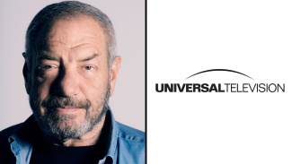

**Wolf**NBCUniversal

The new series, which could be branded as part of the *Law & Order* franchise, is executive produced by Wolf, Arthur W. Forney and Peter Jankowski for [Wolf Entertainment](https://deadline.com/tag/wolf-entertainment/) and Universal TV, a division of NBCUniversal Content Studios. I hear former *Chicago P.D.* showrunner Matt Olmstead is being eyed as writer-showrunner.

A nova série, que poderia ser marcada como parte da franquia *Law & Order,* é produção executivo por Wolf, Arthur W. Forney e Peter Jankowski por [Wolf Entertainment](https://deadline.com/tag/wolf-entertainment/) e Universal TV, uma divisão dos NBCUniversal Content Studios. Eu ouvi que ex-showrunner *Chicago P.D.* Matt Olmstead está sendo olhado como showrunner-escritor.

Like *Law & Order: SVU,* headlined by Mariska Hargitay as Olivia Benson, the new drama is set in New York, allowing for potential seamless crossovers with *SVU* and for Benson-Stabler reunions.

Como em *Law & Order: SVU*, encabeçado por Mariska Hargitay como Olívia Benson, o novo drama está definido em Nova York, permitindo perfeitos potenciais crossovers com *SVU* e para reuniões Benson-Stabler.

With their undeniable onscreen chemistry and great rapport on and off the set, Hargitay and Meloni were one of television’s most popular duos for more than a decade.

Com sua química inegável na tela e ótimo relacionamento dentro e fora do set, Hargitay e Meloni foram uma das mais populares duplas da televisão por mais de uma década.

[Spring Premiere Dates As Networks Adjust Schedules Amid Coronavirus Crisis: Broadcast, Cable &amp; Streaming](https://deadline.com/2020/03/spring-premiere-dates-2020-broadcast-cable-streaming-coronavirus-1202819611/)

Meloni was the male lead opposite Hargitay for *SVU*‘s first 12 seasons, with their characters both partners and best friends. Stabler is an Irish American who, during the time he was featured on *SVU,* was married (his wife Kathy was played by Isabel Gillies) with five children. The role earned Meloni a lead actor in a drama series Emmy nomination in 2006.

Meloni foi o líder masculino oposto de Hargitay para as primeiras 12 temporadas de *SVU*, com seus personagens ambos parceiros e melhores amigos. Stabler é um americano irlandês que, durante o tempo ele foi apresentado no *SVU*, era casado (sua esposa Kathy era interpretada por Isabel Gillies) com cinco crianças. O papel rendeu a Meloni uma nomeação Emmy 2006 como um ator principal em uma série drama.



**Meloni, Hargitay**Universal Tv/Kobal/Shutterstock

Following Meloni’s exit after Season 12, his character was written off, with Stabler abruptly retiring from the police force.

Após a saída de Meloni depois da temporada 12, seu personagem foi descartado, com Stabler abruptamente aposentando da força policial.

Since departing *SVU* in 2011, Meloni headlined the Syfy series *Happy!* and Fox comedy series *Surviving Jack*, starred on the praised WGN America series *Underground* and did memorable arcs on *True Blood* and *The Handmaid’s Tale.*

Desde que partiu de *SVU* em 2011, Meloni foi a atração principal da série SyFy *Happy!* e série de comédia Fox *Surviving Jack*, estrelou na elogiada série WGN América *Underground* e fez arcos memoráveis em *True Blood*  e  *Handmaid’s Tale.*

[2020 NBC Pilots &amp; Series Orders](https://deadline.com/pilot/2020-nbc-pilots-series-orders/)

During his almost nine years away from *SVU*, Meloni remained close with Hargitay and the Wolf family. In January, the former co-stars appeared together, alongside Wolf, in *The Paley Center Salutes Law & Order: SVU* special on NBC. It was around that time that I first heard chatter of a potential new Wolf series with Meloni. Formal conversations started soon thereafter.

Durante seus quase nove anos longe de SVU, Meloni permaneceu próximo com Hargitay e a família Wolf. Em janeiro, os ex-astros apareceram juntos, ao lado de Wolf no especial *The Paley Center Salutes Law & Order: SVU na NBC.*

Meloni is repped by Gersh and Industry Entertainment.

Meloni é representado por Gersh and Industry Entertainment.

On NBC, the new series will join the four existing Dick Wolf series, *SVU* and the three *Chicago* dramas, all of which [received massive three-year renewals](https://deadline.com/2020/02/chicago-fire-chicago-pd-chicago-med-renewed-3-more-seasons-nbc-1202870094/) last month as part of Wolf’s new pact. The network also has been developing a *Law & Order: Hate Crimes* [offshoot series](https://deadline.com/2019/05/law-order-hate-crimes-nbc-boss-confident-series-will-happen-status-update-1202613052/).

Na NBC, a nova série se juntará a quatro séries existentes de Dick Wolf, *SVU* e os três dramas *Chicago*, todos os quais [receberam grandes renovações de três anos](https://deadline.com/2020/02/chicago-fire-chicago-pd-chicago-med-renewed-3-more-seasons-nbc-1202870094/) mês passado como parte do novo pacto de Wolf. A rede também tem desenvolvido [uma série de ramificações](https://deadline.com/2019/05/law-order-hate-crimes-nbc-boss-confident-series-will-happen-status-update-1202613052/) *Law & Order: Hate Crimes*.